KOLLI.TEJASWI

S R K R Bhimavaram, West Godavari Dist: 534199 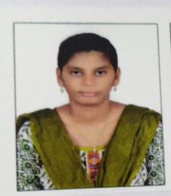

Mobile number : 6305770757

Email address : kollitejaswi9@gmail.com

CAREER OBJECTIVES: To enhance and improve my skills along the growth of the organization, while contributing to the organization with in my ability.

ACADEMIC QUALIFICATIONS:

|  |  |  |  |  |
| --- | --- | --- | --- | --- |
| **COURSE** | BOARD | NAME OF THE INSTITUTION | YEAR OF PASSING | PERCENTAGE/  CGPA |
| ENGINEERING  (Civil Engineering) | JNTU Kakinada | SRKR | 2022 | 8.12 |
| INTERMEDIATE  (M.PC) | Board of Intermediate education | Aditya junior college | 2018 | 96 |
| SSC | Board of secondary education | Aditya [E.M] High School | 2022 | 8.12 |

TECHNICAL SKILLS:

* BASICS OF C LANGUAGE
* AUTOCAD

INTERNSHIP:

Autocad training programme

* Company

: verzeo edu tech

* Project title

: AUTOCAD training programme

* Duration

: 3 months

* Mode

: online

STRENGTHS:

* Puntuality
* Completing the task within the dead line

CO-CIRCULAR ACTIVITIES:

Participated in supernova 2k19:

* Brick Stalwart
* City Scape
* Cad Mania

PERSONNEL DETAILS:

Name : K.Tejaswi

Father Name & Occupation : K.S.CH.Sairam, & Teacher

Mother Name & Occupation : K.H.SS. Maha Lakshmi & House Wife

Address for correspondence : D.NO: 4-183, Santhinagar, Opp to Sai agro industries,

Undi, Andhra Pradesh, W.G Dist,Pin code: 534199

Date of Birth : 05 - June- 2001

Nationality : Indian

Languages : English, Telugu